EU DECLARATION OF CONFORMITY

PPE
Orca v6, Electronically Controlled Closed Circuit Rebreather

Manufacturer
Name: Lungfish Dive Systems Ltd
Address: New Cambridge House, Bassingbourn Road, Litlington, SG8 0SS. U.K.

Declaration
This declaration of conformity is issued under the sole responsibility of the manufacturer:

Object
The PPE described hereafter as the Orca v6 Closed Circuit Rebreather Part no. LF 06000020, LF 06000030, and LF 06000040
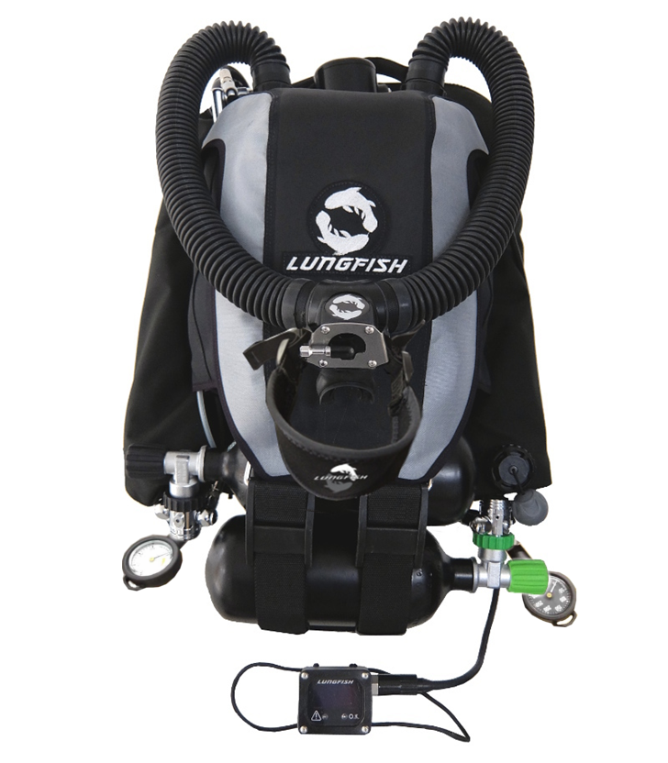

LF 06000020 ORCA v6 (A0) comes supplied with an Electronics Head with a standard size handset (LF 06065020), no extra analogue output ports and no fourth Oxygen Sensor fitted. The Outer Casing can be black/black (LF 06070091) or black/silver (LF 06070012). Pressure gauges are supplied as standard and can be either under arm - 58 cm (LF 06041031 - Diluent and LF 06040052 - Oxygen) or over shoulder – 100 cm (LF 06046271 – Diluent and LF 06040181 – Oxygen).

LF 06000030 ORCA v6 (A1) comes supplied with an Electronics Head with a standard size handset, one extra analogue output port and no fourth Oxygen Sensor fitted The Outer Casing can be black/black (LF 06070091) or black/silver (LF 06070012). Pressure gauges are supplied as standard and can be either under arm - 58 cm (LF 06041031 - Diluent and LF 06040052 - Oxygen) or over shoulder – 100 cm (LF 06046271 – Diluent and LF 06040181 – Oxygen).

LF 06000040 ORCA v6 (A2) comes supplied with an Electronics Head with a large size handset (LF 06065010), two extra analogue output ports and a fourth Oxygen Sensor fitted. The Outer Casing can be black/black (LF 06070091) or black/silver (LF 06070012). Pressure gauges are supplied as standard and can be either under arm - 58 cm (LF 06041031 - Diluent and LF 06040052 - Oxygen) or over shoulder – 100 cm (LF 06046271 – Diluent and LF 06040181 – Oxygen).

Conformity
The object of the declaration described in point 4 is in conformity with the provisions of Module B of the Personal Protective Equipment Regulations (Regulation (EU) 2016/425.

Designated Standards
The Standards Applied are EN 14143:2013 and EN 1809:2014+A1:2016.

Examination
The approved body, SGS Fimko Oy, Takomotie 8, FI-00380 Helsinki. Notified Body No. 0598, has performed the type approval (Module B) and issued the type examination certificate 0598/PPE/24/3049.

Conformity Assessment
The ongoing conformity (Module C2 or D) will be under the surveillance of SGS Fimko Oy, Takomotie 8, FI-00380 Helsinki. Notified Body No. 0598.

Signed for and on behalf of Lungfish Dive Systems Ltd
At New Cambridge House, Litlington, UK
Date: 01/05/2024

..............................................
Stuart Wilson
Director

